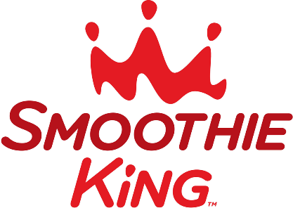

SOMERVILLE
PROJECT GRADUATION
FUNDRAISER

ON FRIDAY, MAY 6, 2016,
SMOOTHIE KING IN BRIDGEWATER, NJ
IS DONATING 15% OF SALES TOWARD PROJECT GRADUATION!!!

ALL YOU HAVE TO DO IS STOP BY ANYTIME BETWEEN
1 pm AND 8 pm on May 6th and mention
PROJECT GRADUATION
when you place your order!!!

